**Project Tittle: Document Tracking System with SMS Notification**

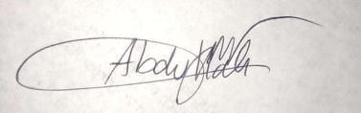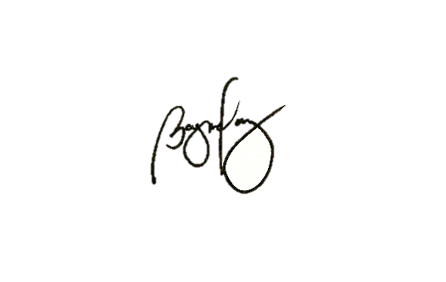

Group Members: Abdullah, Nurullajie S. ______________________

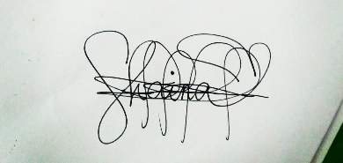 Bagundang, Zarah Mae G. ______________________

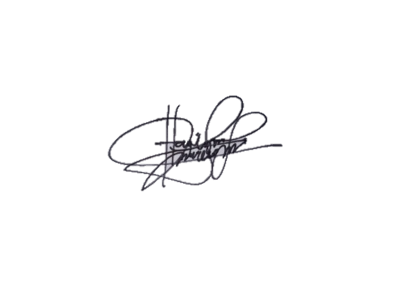 Daud, Sitty Nor-Shaina D. ______________________

Mancao, Nicole Haylynn G. ______________________

Adviser: Mr. Junaidin Kamid ______________________

Panelist: Mr. Aldren Borja ______________________

Panelist: Ms. Nor-Ana Mama ______________________

Panelist: <Name of Panelist> ______________________

Date of defense: June 12, 2021 Time: 1:00 – 2:00 pm

Proponents Name: Comments/Suggestions

Abdullah, Nurullajie S. Say thank you to acknowledge the previous speaker.

Must end the topic properly by calling the name of the next speaker.

Maintain the energy in presenting the topic from beginning up to the end of presentation.

Bagundang, Zarah Mae G. Say thank you to acknowledge the previous speaker.

Must end the topic properly by calling the name of the next speaker.

Maintain the energy in presenting the topic from beginning up to the end of presentation.

The last speaker must end up the entire presentation properly.

Daud, Sitty Nor-Shaina D. Say thank you to acknowledge the previous speaker.

Must end the topic properly by calling the name of the next speaker.

Maintain the energy in presenting the topic from beginning up to the end of presentation.

Mancao, Nicole Haylynn G. The first speaker should introduce the co-proponents.

There is no need for an emcee.

Acknowledge the next speaker by introducing their topic and name.

Say thank you to acknowledge the previous speaker.

**PowerPoint Presentation**

* Do not include all the details of the presentation.
* Outline the topic and avoid including too much text in the presentation.
* The first speaker's topic should cover the introduction part.
* The second speaker should discuss the statement of the problem.
* The third speaker should discuss the objective of the study, scope & limitation.
* The fourth speaker should discuss the significance of the study and conclusion.

**Documents**

* Prepare all of the references that will be needed to support the discussion.

**System**

* The dashboard must include a document organizer that includes document files, videos, and images.
* From the view of the admin user, there should be a search engine on the dashboard to track the received and sent files.
* Employee and other users should have their privacy, and admin users are not required to access or view every document sent to employees.
* Adding document types such as word document, image (jpeg), video (mpeg), and pdf.
* Specify the number of bytes for each document type.
* Allow users to send files to multiple recipients and forward files to other users without restriction.
* Too much process in released documents. There should be one direct form where users can process all transactions in one place.
* Inbox interface where users and admin users can view all the notifications including sent and received files.
* Archiving, which allows users to save, search and view records in a database.
* SMS campaigns must automate the message; options and ready-made (automated) messages for a user.
* Allow users to send SMS to many recipients.
* Each document file must have a unique key value or tracking number (ID number) to identify the specific document file.